Joshua Williamson
CS-330
January 6th, 2025

Module 1-2
The screenshot below was my success of running the code through the Codio lab environment as well as adding my name into the title bar. This was not the first attempt as other attempts through different methods were unsuccessful.
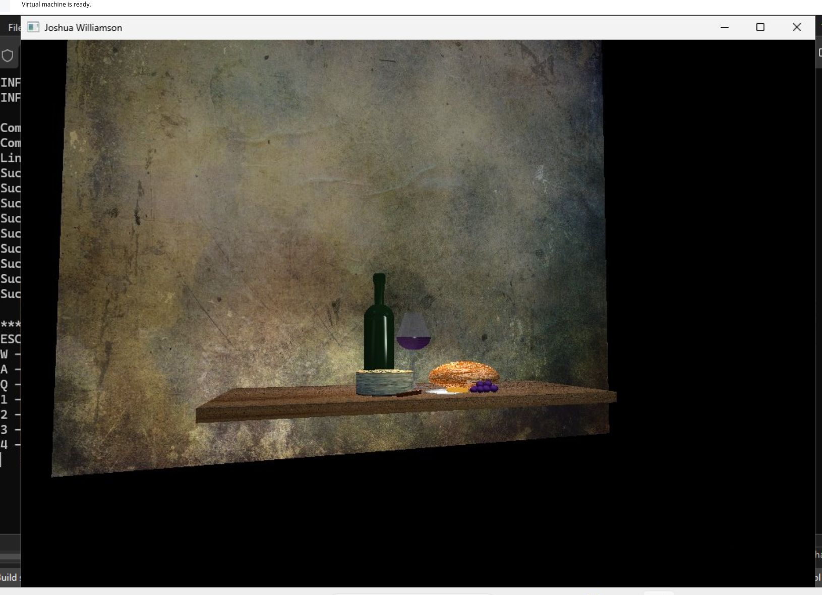

Originally I tried to setup on my desktop environment. However Visual Studios seems to be Windows only. There is a Linux version of Visual Studios Code however digging into this I found it would not be suitable for this exercise. Luckily I have a Windows VM deployed on a HyperVisor environment for situations which I need to run a few Windows applications. I was able to install Visual Studios but after setting up the code editor I ran into an error that the correct Platform Toolset was not installed. Luckily this was fixed quickly as Visual Studios detected it was not installed and able to correct itself. After running the code I ran into this error in the screenshot below:

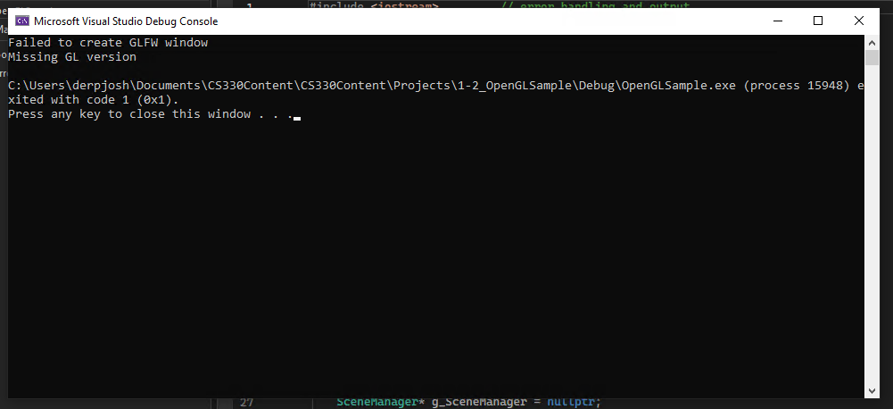

Searching into this the issue, the problem appears to be with my setup itself and not the code or Visual Studios. As the system itself does not have a dedicated GPU installed I am not able to configure GPU pass through to allow the VM to utilize a graphics card. As such the code will not render the objects. As such my only choice is to use the Codio lab environment for the course work. It was a fun exercise to see if I can the code through my virtual environment but without a dedicated GPU for these tasks I am not able to at this time.

